TAKE HOME—Exam one 402
63 points
Name____________________________________________ ID number_______________________________________
Take home: This take home portion of the exam is an “open book” exam, but your research is restricted to the material on the website. Please use only the guide and links provided to answer all questions. Discussing questions with students in the class, other students, past students and any other contacts is considered a breach of the honor code.

Answer to questions should represent your and only your efforts to master the material. If two exams are deemed the effort of more than one individual, all individuals involved will receive a 0 on their exams.

Please try to follow my suggestions for answer length. If I ask for ½ of a page of text for an answer, I will not grade two pages. I will not give any one student, any consideration I cannot give to all.

1. You are given the following fossil and told it is not an arthropod. What is the one question about the unknown internal anatomy of the animal that would decide if it definitely belonged in one of the following clades? (Use defining characters, synapomorphies, for the clades if you can.) 4 points.
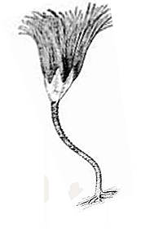 | Cnidaria  Echinoderma

2.Homologies and bauplans. (½ page of text per answer please—at least 12 point type)
You learned that bat and bird wings were not homologous.
https://evolution.berkeley.edu/evolibrary/article/0_0_0/evo_09 13 points

- Can the same reasoning be applied to the segmentation we see in annelids and arthropods?
- Segmentation is considered a bauplan characteristic. If such characteristics are not homologous, can they tell us anything about one group’s relationships to others? If not, then of what use are bauplans?

3. Why are the changes in animal form associated with the Cambrian period considered a genetic as well as morphological “revolution “ in animal design? (1/2 page of text please—12 point type.) 6 points.

4. Correct all the errors in the following statements. There is at least one error in every statement. Some statements may contain two errors. You do not have to rewrite the statement. Simply indicate the term you wish to replace and place the correction following the term to be replace.
For example: Annelids belong to the kingdom Plantae.
Your answer: Plantae (substitute Animalia) 12 points

a. Arthropods can have a compound eye that consists of one large lens, which easily adjusts for depth of field, and has a high flicker fusion rate.

b. Muscle fibers of arthropods are almost all smooth muscle and innervated, as vertebrate muscle fibers, by one neuron.

c. The larger the arthropod, the less the danger that during the molt the body will collapse on itself. Also the larger the arthropod the smaller the ratio of the weight of the animal divided by the diameter of its appendages.

d. Crustaceans breathe by tracheae; in spiders only book gills are used in respiration.

5. What is a distributed foot? What appendages are Daphnia using as a distributed foot? 1/3 of a page of text please. 7 points.

Questions 6 will also be counted toward 15 points of homework on this material.
Examine the following diagrams. For the diagrams indicate which group of Arthropoda (such as arachnids, myriapodia or millipedes and centipedes, etc.) the animal belongs to that is diagrammed. Briefly describe how you determined this, using tagminization and other structural characteristics. Identify the Arthropod group, not the particular animal diagrammed. 15 points

Do not simply google these images, because no credit will be given for right answers with no or wrong justification. Justification has to be based solely on the material made available to you on the course website or in the laboratory.

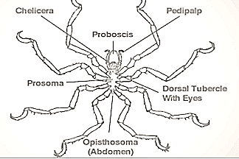 | 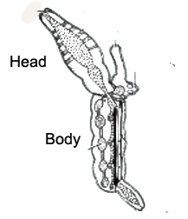internal anatomy  Group_____________________
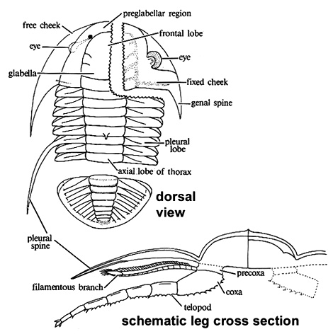 | Group__________________
Larvae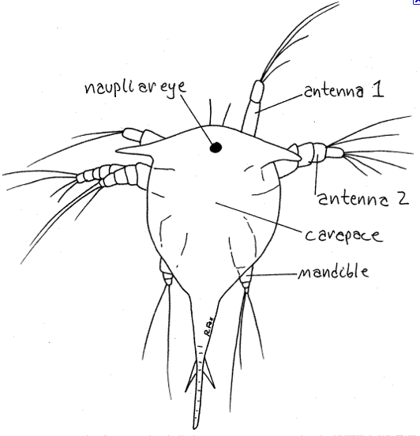  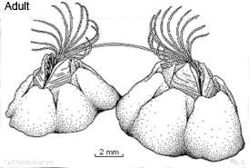 | Group__________________

7. Discuss (a) the way Horseshoe crab blood is used to test for sterility in medical products.
You must include those aspects of the Horseshoe crab’s physiology that allows such use. ½ page of text please. 6 pts.

